Name: Ajmal Rahman A
Register Number: 192324094
Course Code & Name: CSA0409-Operating Systems
Date: 09-07-2026

1. DISPLAY CURRENT PROCESS ID OF A RUNNING PROGRAM

#include <stdio.h>
#include <unistd.h>
int main(){
printf("Current Process ID (PID): %d \n",getpid());
return 0;
}
OUTPUT:
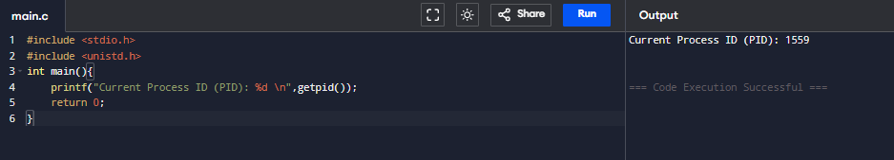
2. CREATE 2 CHILD PROCESS ID'S AND PRINT THEIR ID'S

#include <stdio.h>
#include <unistd.h>
#include <sys/types.h>

int main() {
pid_t pid1, pid2;

pid1 = fork();

if (pid1 == 0) {
printf("First Child Process\n");
printf("Child 1 PID: %d\n", getpid());
} else {
pid2 = fork();

if (pid2 == 0) {
printf("Second Child Process\n");
printf("Child 2 PID: %d\n", getpid());
} else {
printf("Parent Process\n");
printf("Parent PID: %d\n", getpid());
printf("First Child PID: %d\n", pid1);
printf("Second Child PID: %d\n", pid2);
}
}

return 0;
}
OUTPUT:
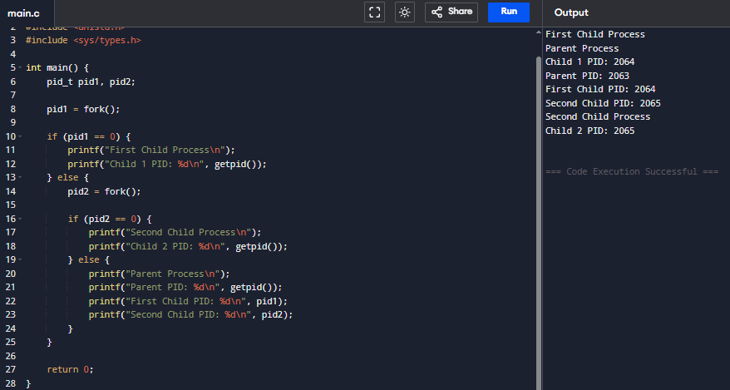
3. SIMULATE A READY QUEUE USING A QUEUE DATA STRUCTURE

#include <stdio.h>
#define MAX 10

int queue[MAX];
int front = -1, rear = -1;

void enqueue(int pid) {
if (rear == MAX - 1) {
printf("Ready Queue is Full!\n");
return;
}
if (front == -1)
front = 0;

rear++;
queue[rear] = pid;
printf("Process %d added to Ready Queue.\n", pid);
}

void dequeue() {
if (front == -1 || front > rear) {
printf("Ready Queue is Empty!\n");
return;
}

printf("Process %d is executing.\n", queue[front]);
front++;

if (front > rear)
front = rear = -1;
}

void display() {
int i;

if (front == -1) {
printf("Ready Queue is Empty!\n");
return;
}

printf("Ready Queue: ");
for (i = front; i <= rear; i++) {
printf("%d ", queue[i]);
}
printf("\n");
}

void peek() {
if (front == -1)
printf("Ready Queue is Empty!\n");
else
printf("Next Process to Execute: %d\n", queue[front]);
}

int main() {
int choice, pid;

while (1) {
printf("\n--- Ready Queue Simulation ---\n");
printf("1. Add Process\n");
printf("2. Execute Process\n");
printf("3. Display Ready Queue\n");
printf("4. Peek Front Process\n");
printf("5. Exit\n");
printf("Enter your choice: ");
scanf("%d", &choice);

switch (choice) {
case 1:
printf("Enter Process ID: ");
scanf("%d", &pid);
enqueue(pid);
break;

case 2:
dequeue();
break;

case 3:
display();
break;

case 4:
peek();
break;

case 5:
return 0;

default:
printf("Invalid Choice!\n");
}
}

return 0;
}
OUTPUT:
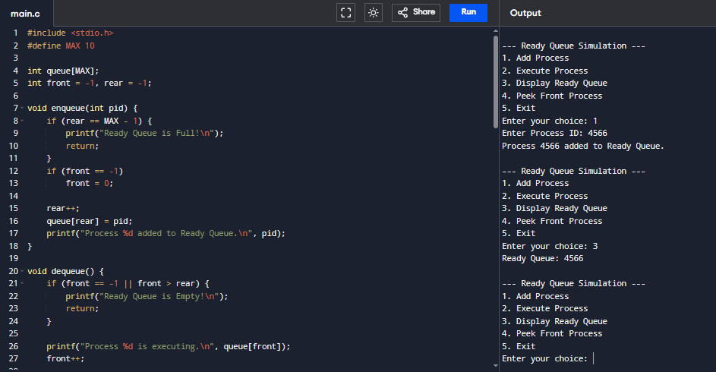
4. SIMULATE A SIMPLE SCHEDULER THAT EXECUTES PROCESSES ONE BY ONE

#include <stdio.h>

int main() {
int n, i, p[10];

printf("Enter number of processes: ");
scanf("%d", &n);

for(i = 0; i < n; i++) {
printf("Enter Process ID: ");
scanf("%d", &p[i]);
}

printf("\nExecution Order:\n");
for(i = 0; i < n; i++) {
printf("Executing Process %d\n", p[i]);
}

return 0;
}
OUTPUT:
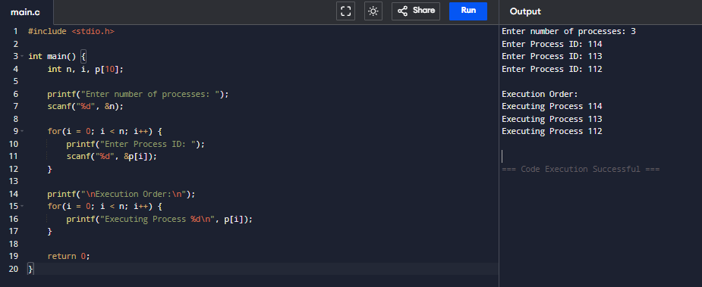
5. READ AND WRITE DATA USING FILE SYSTEM CALLS

#include <stdio.h>
#include <fcntl.h>
#include <unistd.h>
#include <string.h>
#include <stdlib.h>

int main() {
int fd;
char data[] = "Hello Operating System";
char buffer[100];

fd = open("sample.txt", O_CREAT | O_RDWR | O_TRUNC, 0644);

if (fd == -1) {
perror("Error opening file");
exit(1);
}

write(fd, data, strlen(data));

lseek(fd, 0, SEEK_SET);

int bytes = read(fd, buffer, sizeof(buffer) - 1);

if (bytes == -1) {
perror("Error reading file");
close(fd);
exit(1);
}

buffer[bytes] = '\0'; // Null terminate the string

printf("Data Read: %s\n", buffer);

close(fd);

return 0;
}
OUTPUT:
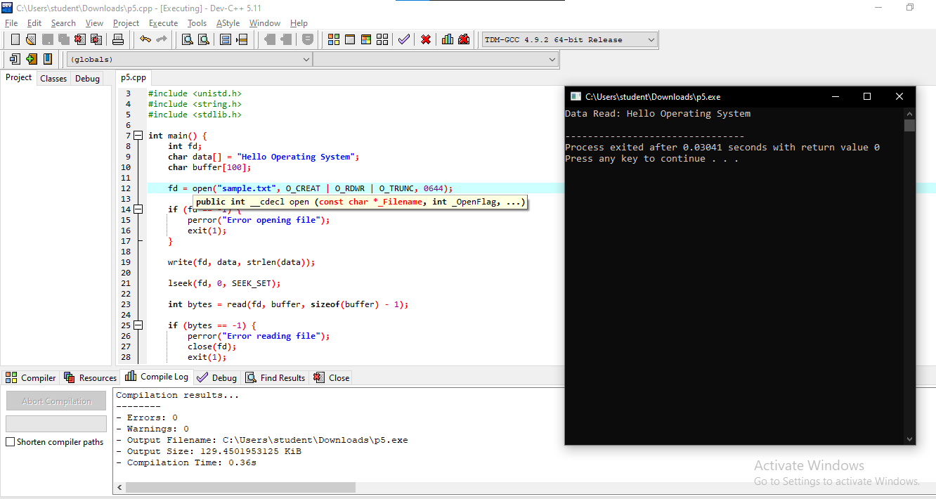

6. SIMULATE PAGE REPLACEMENT USING A LIST OR QUEUE

#include <stdio.h>

int main() {
int frames[3], pages[] = {1,2,3,4,1,2,5};
int i, j, front = 0, faults = 0, found;

for(i=0;i<3;i++)
frames[i] = -1;

for(i=0;i<7;i++) {
found = 0;

for(j=0;j<3;j++) {
if(frames[j] == pages[i]) {
found = 1;
break;
}
}

if(!found) {
frames[front] = pages[i];
front = (front + 1) % 3;
faults++;
}
}

printf("Page Faults = %d\n", faults);

return 0;
}
OUTPUT:
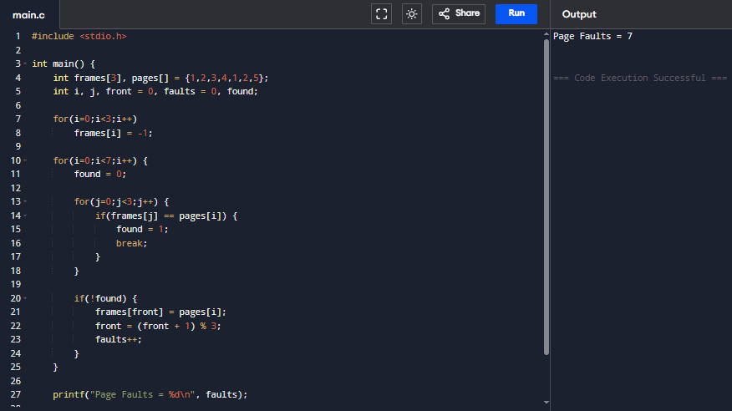

7. ALLOCATE MEMORY BLOCKS USING ARRAYS

#include <stdio.h>

int main() {
int block[] = {100, 500, 200, 300};
int process[] = {212, 417, 112};
int i, j;

for(i=0;i<3;i++) {
for(j=0;j<4;j++) {
if(block[j] >= process[i]) {
printf("Process %d allocated to Block %d\n", process[i], j+1);
block[j] -= process[i];
break;
}
}

if(j==4)
printf("Process %d Not Allocated\n", process[i]);
}

return 0;
}
OUTPUT:
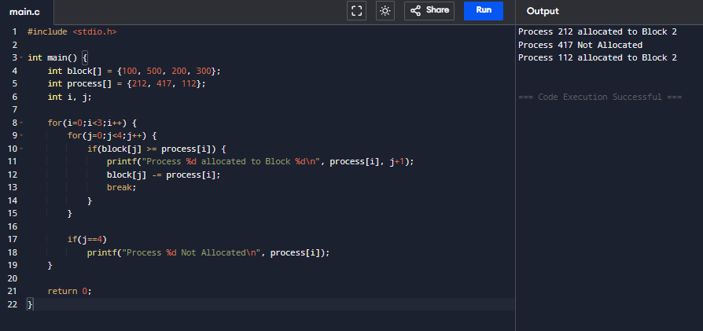

8. CREATE 2 THREADS THAT PRINT NUMBERS ALTERNATELY

#include <stdio.h>
#include <pthread.h>

void *even(void *arg) {
int i;
for(i=2;i<=10;i+=2)
printf("Even: %d\n", i);
return NULL;
}

void *odd(void *arg) {
int i;
for(i=1;i<=9;i+=2)
printf("Odd : %d\n", i);
return NULL;
}

int main() {
pthread_t t1, t2;

pthread_create(&t1, NULL, odd, NULL);
pthread_create(&t2, NULL, even, NULL);

pthread_join(t1, NULL);
pthread_join(t2, NULL);

return 0;
}

OUTPUT:
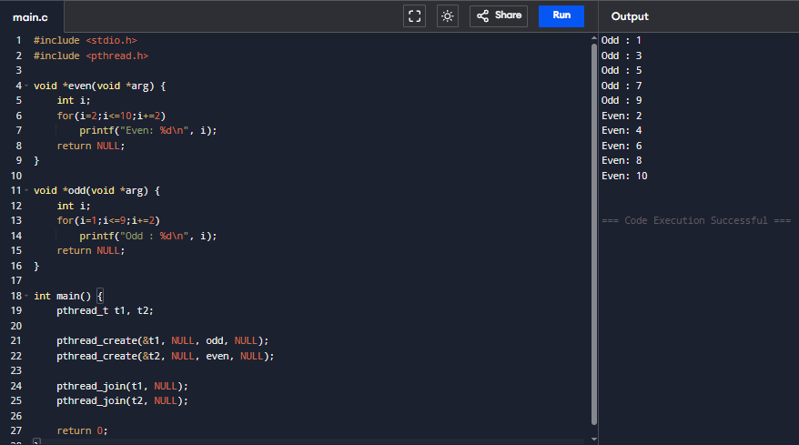

9. IMPLEMENT A BOUNDED BUFFER USING A QUEUE

#include <stdio.h>

#define SIZE 5

int buffer[SIZE];
int front = -1, rear = -1;

void produce(int item) {
if(rear == SIZE-1) {
printf("Buffer Full\n");
return;
}

if(front == -1)
front = 0;

buffer[++rear] = item;
}

void consume() {
if(front == -1 || front > rear) {
printf("Buffer Empty\n");
return;
}

printf("Consumed: %d\n", buffer[front++]);

if(front > rear)
front = rear = -1;
}

int main() {
produce(10);
produce(20);
produce(30);

consume();
consume();

return 0;
}
OUTPUT:
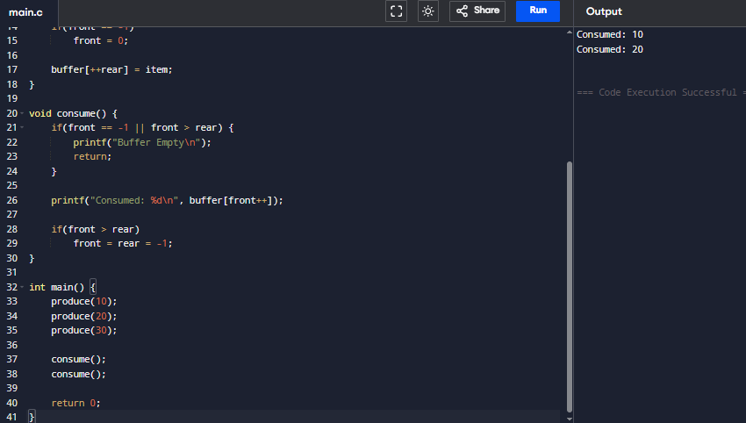

10. CALCULATE AVERAGE WAITING TIME FOR A GIVEN LIST OF PROCESSES

#include <stdio.h>

int main() {
int n, bt[10], wt[10];
int i;
float avg = 0;

printf("Enter number of processes: ");
scanf("%d", &n);

for(i=0;i<n;i++) {
printf("Burst Time P%d: ", i+1);
scanf("%d", &bt[i]);
}

wt[0] = 0;

for(i=1;i<n;i++)
wt[i] = wt[i-1] + bt[i-1];

printf("\nProcess\tBurst\tWaiting\n");

for(i=0;i<n;i++) {
printf("P%d\t%d\t%d\n", i+1, bt[i], wt[i]);
avg += wt[i];
}

printf("\nAverage Waiting Time = %.2f\n", avg / n);

return 0;
}
OUTPUT:
